**Name: Jain Apurva Sanjay Class:MCA(Sem 1)Div:A**

**Roll No: 12**

**Set - 1**

1. **Create the Simple DEPARTMENT Table**

Create table Department

(

dept\_no integer primary key not null,

dept\_name varchar(250),

location varchar(200)

);

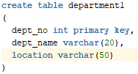

1. **Display structure of department table.**

desc Department;

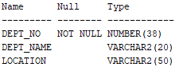

1. **Insert below records into the Department Table:** **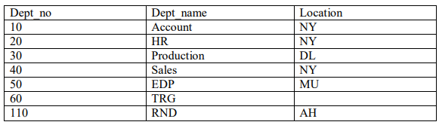**

insert into Department values(10,'Account','NY');

insert into Department values(20,'HR','NY');

insert into Department values(30,'Production','DL');

insert into Department values(40,'Sales','NY');

insert into Department values(50,'EDP','MU');

insert into Department values(60,'TRG','NY');

insert into Department values(110,'RND','AH');

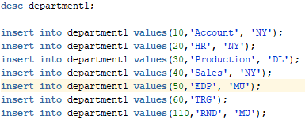

**Name: Jain Apurva Sanjay Class:MCA(Sem 1)Div:A**

**Roll No: 12**

1. **Display all records of the Department table.**

select \* from department1;

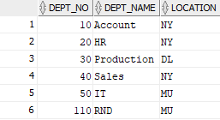

1. **Display all department belonging to location 'NY'.**

select \* from department1 where location = 'NY';

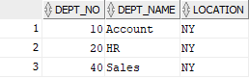

1. **Display details of Department 10.**

select \* from department1 where dept\_no = 10;

IMG_256

1. **List all department names starting with 'A'.**

select \* from department1 where dept\_name like 'A%';

IMG_256

1. **List all departments whose number is between 1 and 100.**

select \* from department1 where dept\_no between 1 and 100;

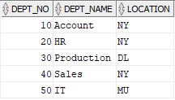

1. **Delete 'TRG' department.**

delete from department1 where dept\_name = 'TRG';

IMG_256

**Name: Jain Apurva Sanjay Class:MCA(Sem 1)Div:A**

**Roll No: 12**

**10.) Change department name 'EDP' to 'IT.**

update department1 set dept\_name ='IT' where dept\_name = 'EDP';

IMG_256

**Name: Jain Apurva Sanjay Class:MCA(Sem 1)Div:A**

**Roll No: 12**

**Set - 2**

**EMPLOYEE (emp\_id, emp\_name, birth\_date, gender, dept\_no, address, designation, salary, experience, email) DEPARTMENT (dept\_no, dept\_name, location)**

1. **Create the EMP Table with all necessary constraints such as In EMP TABLE: Employee id should be primary key, Department no should be Foreign key, employee age (birth\_date) should be greater than 18 years, salary should be greater than zero, email should have (@ and dot) sign in address, designation of employee can be “manager”, “clerk”, “leader”, “analyst”, “designer”, “coder”, “tester”**

create table employee

(

emp\_id int primary key,

emp\_name varchar(200),

birth\_date date,

gender varchar(6),

address varchar(100),

designation varchar(15),

salary int,

experience varchar(5),

email varchar(255),

dept\_no int,

constraint chk\_sal check(salary>0),

constraint chk\_designation check(designation in ('manager', 'clerk', 'leader', 'analyst','designer', 'coder', 'tester')),

foreign key(dept\_no) references Department(dept\_no)

);

1. **Create DEPT table with necessary constraint such as Department no should be the primary key, department name should be unique.**

Create table Department

(

dept\_no integer primary key not null,

dept\_name varchar(250),

location varchar(200)

);

1. **After creation of above tables, modify Employee table by adding the constraints as ‘Male’ or ‘Female’in gender field.**

alter table employee add constraint check\_gender CHECK ( gender in ('Male','Female') );

1. **Insert proper data (at least 5 appropriate records) in all the tables.**

insert into employee values(1001, 'Apurva', '2003-03-24', 'Male', 101, 'SURAT', 'Manager', 200000, 5, 'apurvajain.mca12@scet.ac.in');

insert into employee values(1002,'Sakshi', '2002-11-12', 'Female', 201, 'SURAT', 'Tester', 100000, 3, 'sakshipatel13.mca12@scet.ac.in');

insert into employee values(1003, 'Purva', '2000-08-25', 'Male', 301, 'Surat', 'Analyst', 100000, 6, 'purvajain25.mca12@scet.ac.in');

insert into employee values(1004, 'Alka', '1975-06-21', 'Female', 401, 'SURAT','Coder', 90000, 3, 'alkajain.mca21@scet.ac.in');

**Name: Jain Apurva Sanjay Class:MCA(Sem 1)Div:A**

**Roll No: 12**

insert into employee values(1005, 'Sanjay', '1975-03-11', 'MALE', 501, 'SURAT', 'Leader', 500000, 10, 'sanjayjain11.mca21@scet.ac.in');

insert into employee values(1006, 'Kanu', '1981-02-15', 'MALE', 601, 'SURAT', 'Clerk', 1000000, 6, ['sanjayjain15.mca21@scet.ac.in');](mailto:'sanjayjain15.mca21@scet.ac.in');)

1. **Display the structure of Table.**

desc employee;

desc department;

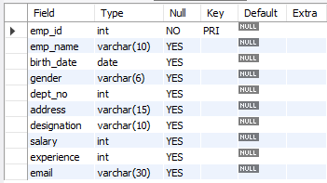



1. **List all records of each table in ascending order.**

select \* from Employee order by emp\_id;

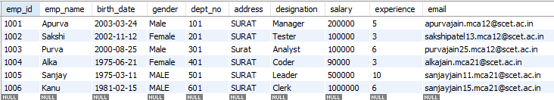

1. **Delete the department whose loction is Ahmedabad.**

delete from DEPARTMENT where location = 'Ahmedabad';



1. **Display female employee list.**

select \* from employee where gender = 'Female';



**Name: Jain Apurva Sanjay Class:MCA(Sem 1)Div:A**

**Roll No: 12**

1. **Display Department namewise employee names.**

select d.dept\_name, e.emp\_name FROM EMPLOYEE e JOIN DEPARTMENT d ON e.dept\_no = d.dept\_id ORDER BY d.dept\_name;

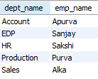

1. **Find the names of the employee who has salary less than 5000 and greater than 2000.**

select \* from employee where salary between 2000 and 5000;



1. **Display the names and the designation of all female employee in descending order.**

Select emp\_name, designation from employee where gender = ‘Female’ order by emp\_name desc;



1. **Display the names of all the employees who names starts with ‘A’ ends with ‘A’.**

select emp\_name from employee where emp\_name like 'A%A'



1. **Find the name of employee and salary for those who had obtain minimum salary.**

select emp\_name, salary from empolyee where salary = (select min(salary) from employee);



1. **Add 10% raise in salary of all employees whose department is ‘IT’.**

update employee set salary = salary \* 1.10 where dept\_no in (select dept\_id from department where dept\_name = 'IT');



**Name: Jain Apurva Sanjay Class:MCA(Sem 1)Div:A**

**Roll No: 12**

1. **Count total number of employees of ‘IT’ department.**

select count(\*) "count " from employee , department where employee.dept\_no = department.dept\_no and dept\_name = 'IT';



1. **List all employees who born in the current month.**

select \* from employee where extract(month from birth\_date) = extract(month from current\_date);



1. **Print the record of employee and dept table as “Employee works in department ‘MBA’.**

select concat('employee works in department ', department.dept\_name) as record

from employee join department on employee.dept\_no = department.dept\_id;

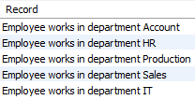

1. **List names of employees who are fresher’s (less than 1 year of experience).**

select \* from employee where experience = 0;



1. **List department wise names of employees who has more than 5 years of experience.**

select department.dept\_name, employee.emp\_name from employee join department on employee.dept\_no = department.dept\_id where employee.experience > 5;



1. **Create Sequence to generate department ID.**

create table department

(

dept\_id int auto\_increment primary key,dept\_name varchar(10) unique,location varchar(10)

);

**Name: Jain Apurva Sanjay Class:MCA(Sem 1)Div:A**

**Roll No: 12**

1. **Create Sequence to generate department ID.**

create table department

(

dept\_id int auto\_increment primary key,dept\_name varchar(10) unique,location varchar(10)

);

1. **List department having no employees.**

select emp\_name from emp where dept\_id not in (select dept\_id

from department);



**Name: Jain Apurva Sanjay Class:MCA(Sem 1)Div:A**

**Roll No: 12**

**Set - 3**

1. **Create the above three tables along with key constraints.**

create table student

(

rollno int(10) primary key,

name varchar(50),

class int(10),

birthdate date

);

create table course

(

courseno int(10) primary key,

coursename varchar(50),

max\_marks int(10),

pass\_marks int(10)

);

create table SC

(

rollno int(10) primary key,

courseno int(10),

marks int(10)

foreign key (rollno) references student(rollno),

foreign key (courseno) references course(courseno)

);

1. **Write an Insert script for insertion of rows with substitution variables and insert appropriate data.**

insert into course (courseno, coursename, max\_marks, pass\_marks)

values (1001, 'OOPJ', 100, 33);

insert into course (courseno, coursename, max\_marks, pass\_marks)

values (1002, 'DSA', 100, 33);

insert into course (courseno, coursename, max\_marks, pass\_marks)

values (1003, 'RDBMS', 100, 33);

insert into course (courseno, coursename, max\_marks, pass\_marks)

values (1004, 'SP', 100, 33);

insert into course (courseno, coursename, max\_marks, pass\_marks)

values (1005, 'MATHS', 100, 33);

insert into student (rollno, name, class, birthdate) values (101, 'Apurva', 'MCA', '1980- 2-07');

insert into student (rollno, name, class, birthdate) values (102, 'Purva', 'MC', '1981-03 -19');

insert into student (rollno, name, class, birthdate) values (103, 'Alka', 'B.Com', '1987- 10-26');

insert into student (rollno, name, class, birthdate) values (104, 'Sanjay', 'M.Tech', '1990-04-09');

insert into student (rollno, name, class, birthdate) values (105, 'Sakshi', 'B.Tech', '2000-12-17');

insert into SC values(102,1,75);

insert into SC values(101,1,80);

insert into SC values(102,2,80);

**Name: Jain Apurva Sanjay Class:MCA(Sem 1)Div:A**

**Roll No: 12**

insert into SC values(1011,2,30);

insert into SC values(103,1,85);

insert into SC values(103,2,90);

insert into SC values(103,3,95);

1. **Add a constraint that the marks entered should strictly be between 0 and 100.**

alter table SC add constraint marks\_range check (marks >= 0 and marks <= 100);

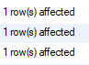

1. **While creating SC table, composite key constraint was forgotten. Add the composite key now.**

alter table sc ADD PRIMARY KEY (rollno,courseno);

1. **Display details of students who take the ‘RDBMS’course.**

select Student.\* from Student,Course,SC where Student.rollno = SC.rollno and Course.courseno = SC.courseno and coursename = 'RDBMS';



1. **Display the names of students who have scored more than 70% in Computer Networksand have not failed in any subject.**

select c.coursename, c.max\_marks, s.name,s1.marks from sc s1, student s, course c where s1.rollno=s.rollno and s1.courseno=c.courseno and round((s1.marks/c.max\_marks)\*100)>70;

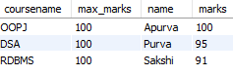

1. **Display the average marks obtained by each student.**

select avg(marks) from sc where rollno in (select rollno from student where name =’Purva');



1. **Select all courses where passing marks are more than 30% of average maximum mark.**

select \* from course where pass\_marks > (select avg(max\_marks)\*30/100 from course);

**Name: Jain Apurva Sanjay Class:MCA(Sem 1)Div:A**

**Roll No: 12**

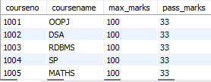

1. **Display details of students who are born in 1980 or 1982.**

select name,birthdate from student where extract(year from birthdate)>=1980 and extract(year from birthdate)<=1982;



1. **Create a view that displays student courseno and its corresponding marks.**

create view student\_marks as select s.name,c.courseno,s1.marks from sc s1, course c,student s where s1.rollno=s.rollno and s1.courseno=c.courseno order by s.name ;



**Name: Jain Apurva Sanjay Class:MCA(Sem 1)Div:A**

**Roll No: 12**

**Set - 4**

**Create the database COMPANY and create given tables with all necessary constraints such as primary key, foreign key, unique key, not null and check constraints.**

**EMPLOYEE (emp\_id, emp\_name, birth\_date, gender, dept\_no, address, designation, salary, experience, email)**

**DEPART (dept\_no, dept\_name, total\_employees, location)**

**PROJECT (proj\_id, type\_of\_project, status, start\_date, emp\_id)**

**Insert proper data (at least 5 appropriate records) in all the tables.**

create table Depart

(

dept\_no int primary key,

dept\_name varchar(20),

total\_employees int,

loc varchar(50)

);

insert into depart values(101, 'BE', 5, 'MH');

insert into depart values(201, 'BTECH', 9, 'GUJRAT');

insert into depart values(301, 'IT', 10, 'TAMIL NADU');

insert into depart values(401, 'ARCHITECT', 10, 'KERALA');

insert into depart values(501, 'DESIGN', 0, 'PUNJAB');

create table employee

(

emp\_id int primary key,

emp\_name varchar(20),

birth\_date date,

gender varchar(6),

dept\_no int REFERENCES department(dept\_no),

address varchar(100),

designation varchar(15) ,

salary int ,

experience int,

email varchar(255),

constraint chk\_desig CHECK(designation in ('manager', 'clerk', 'leader', 'analyst','designer', 'coder', 'tester')),

constraint chk\_sal CHECK (salary>0),

constraint chk\_emp\_email CHECK (email like '%@%' and email like '%.%')

);

insert into employee values(100, 'John', '2000-05-10', 'MALE', 10, 'New York', 'manager', 80000, 8, 'john@email.com');

insert into employee values(101, 'Alice', '1999-09-15', 'FEMALE', 10, 'New York', 'coder', 60000, 6, 'alice@email.com');

insert into employee values(103, 'Michael', '2001-03-20', 'MALE', 30, 'San Francisco', 'leader', 90000, 7, 'michael@email.com');

**Name: Jain Apurva Sanjay Class:MCA(Sem 1)Div:A**

**Roll No: 12**

insert into employee values(104, 'Emily', '2000-04-05', 'FEMALE', 20, 'Los Angeles', 'analyst', 55000, 3, 'emily@email.com');

insert into employee values(105, 'William', '2001-08-18', 'MALE', 40, 'Chicago', 'designer', 70000, 5, ['william@email.com');](mailto:'william@email.com');)

insert into employee values(106, 'Olivia', '2002-01-30', 'FEMALE', 40, 'Chicago', 'tester', 45000, 2, 'olivia@email.com');

create table project

(

proj\_id int primary key,

type\_of\_project varchar(20),

status varchar(20),

start\_date date,

emp\_id int references employee(emp\_id)

);

insert into project values(10, 'IT', 'completed', '2010-03-15', 1001);

insert into project values(20, 'Engineering', 'in-progress', '2011-07-20', 1002);

insert into project values(30, 'Marketing', 'pending', '2008-09-10', 1003);

insert into project values(40, 'Research', 'in-progress', '2012-04-05', 1004);

insert into project values(50, 'Finance', 'completed', '2013-11-25', 1005);

1. **Delete the department whose total number of employees less than 1.**

delete from depart where total\_employees <1;

1. **Display the names and the designation of all female employee in descending order.**

select emp\_name,designation from employee where gender = 'FEMALE' order by emp\_name desc;



1. **Display the names of all the employees who names starts with ‘A’ ends with ‘A’.**

select \* from employee where emp\_name like 'A%a';



1. **Find the name of employee and salary for those who had obtain minimum salary.**

select emp\_name,salary from employee where salary = ( select MIN(salary) from employee );

1. **Add 10% raise in salary of all employees whose department is ‘CIVIL’.**

update employee set salary = salary + (salary\* 0.1) where emp\_id in (select emp\_id from employee,depart where employee.dept\_no = depart.dept\_no and dept\_name = 'CIVIL');

**Name: Jain Apurva Sanjay Class:MCA(Sem 1)Div:A**

**Roll No: 12**

1. **Count total number of employees of ‘MCA’ department.**

select count(\*) "count" from employee,depart where employee.dept\_no = depart.dept\_no and dept\_name = 'MCA';



1. **List all employees who born in the current month.**

select \* from employee where extract(month from birth\_date) = extract(month from current\_date);



1. **Print the record of employee and dept table as “Employee works in department ‘CE’.**

select \* from employee,depart where employee.dept\_no = depart.dept\_no and DEPT\_NAME = 'IT';



1. **List names of employees who are fresher’s(less than 1 year of experience).**

select emp\_name from employee where experience <= 1;



1. **List department wise names of employees who has more than 5 years of experience.**

select emp\_name from employee,depart where employee.dept\_no = depart.dept\_no and experience > 5 order by dept\_name;



1. **Write a function which will display total number of projects based on status (pass status as parameter).**

CREATE OR REPLACE FUNCTION SET4Q11(status1 in varchar)

return

numberis

total number;

BEGIN

select count(\*) into total from project where status = status1;

return total;

END;

setserveroutput

on;declare

total number(1);

begin

total:=SET4Q11('complete');

dbms\_output.put\_line('Total Projectis'||total);

end;